**Exam 2: Problem Solving (35 points)**

**Instructions:**

1. This is an **individual** exam.
2. This is the second part of the two part exam. First part is the multiple choice portion available separately.
3. Provide your responses on this file, save it, and upload the file to the appropriate assignment response in blackboard.
4. You may upload **only one** attempt.
5. Do not handwrite any responses.
6. If you have any additional information you would like me to know about this assignment, you may provide that to me at the end of this document as a note.
7. List and very briefly (one line) describe the 3 types of anomalies that may occur in tables **(2 X 3 = 6 points)**

**Update Anomalies – creates duplicate data when new rows are created**

**Insertion Anomalies – loss of potentially important data when rows are deleted**

**Deletion Anomalies – automatic changes in duplicated rows causes problems**

1. List 3 prerequisites for a relation to be in 1NF **(1 X 3 = 3 points)**

*Full dependencies, partial dependencies, transitive dependencies*

1. Provide the definition of 2nd Normal Form (2NF) **(3 points)**

*A table is in 2NF when partial dependencies are removed, but there are still transitive dependencies*.

1. Provide the definition of 3rd Normal Form (3NF) **(3 points)**

*A table is in 3NF when both partial dependencies and transitive dependencies are removed*.

1. Refer to the ENROLLMENT relation below in answering the questions. Use only the data provided in the table to answer the questions.

**ENROLLMENT**

|  |  |  |  |  |  |  |  |
| --- | --- | --- | --- | --- | --- | --- | --- |
| **Student Id** | **Student Name** | **Advisor Id** | **Advisor Name** | **Term** | **Class Number** | **Class Name** | **Schedule** |
| 101 | Bill Milatur | 902 | Sandeep Goyal | Spring | CIS 3777 | Database | TR 11:00-12:20 |
| 102 | Tom Morrow | 909 | Dave Thomas | Spring | CIS 3293 | Analytics | TR 2:00-3:20 |
| 103 | Sharon Cash | 903 | Jake Jones | Spring | CS 5213 | ERP I | MW 3:30-4:50 |
| 103 | Sharon Cash | 903 | Jake Jones | Spring | CIS 3393 | Software Dev | TR 8:00-9:20 |
| 104 | Stan Doff | 902 | Sandeep Goyal | Spring | CS 3777 | Database | TR 11:00-12:20 |
| 104 | Stan Doff | 902 | Sandeep Goyal | Spring | CIS 5213 | ERP I | MW 3:30-4:50 |
| 105 | Crystal Ball | 903 | Jake Jones | Spring | CS 5223 | ERP II | MW 2:00-3:20 |
| 105 | Crystal Ball | 903 | Jake Jones | Fall | CS 5233 | ERP III | TR 12:00-1:20 |

The following functional dependencies were inferred from the data in this table shown above:

**Full: Student Id, Term, Class Number**

**Partial Functional: Student Id 🡪 Student Name, Advisor Id, Advisor Name**

**Partial Functional: Class Number 🡪 Class Name, Schedule (could be part of full)**

**Transitive: Advisor Id 🡪 Advisor Name**

* 1. What normal form is the ENROLLMENT relation currently in? Why? **(4 points)**

*1NF, because there are partial and transitive dependencies.*

* 1. If ENROLLMENT relation is not in 3NF, normalize this table so it meets 3NF. You may either draw a set of normalized relations (boxes and lines) or a “data model” (ERD). You must include primary and foreign keys and how they are linked to each other. Also highlight the assumptions, if any, that you are making. **(16 points)**

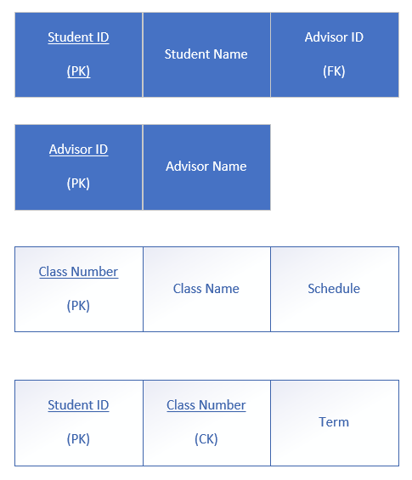

Student ID and Class Number in the last line of boxes makes class number a composite key rather than a primary key.